Jasper Pictorial Appendix

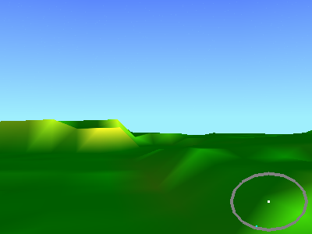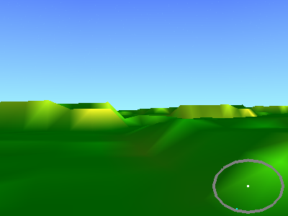
Figure 1: Infinite landscape. When a new tile is needed, it is generated.


Figure 2: Random land tile generated by “Goo” algorithm.

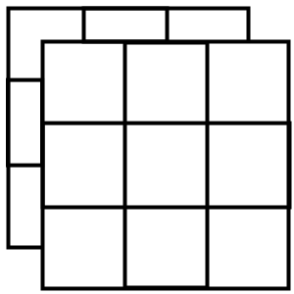
Figure 3: 18 Landscape tiles are generated.

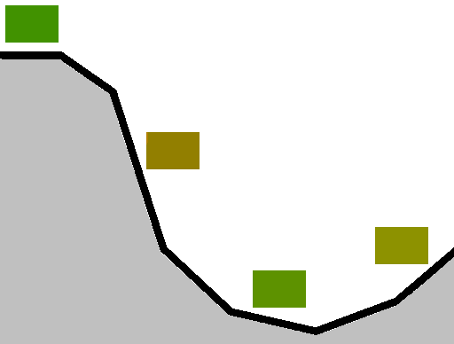
Figure 4: The colour at each point is calculated by its gradient.

Linear Influence = 1-ratio
Smooth Influence = (COS(ratio*PI)+1)/2
Figure 5: Non-linear influence relationship. As used in sky and landscape colouring.

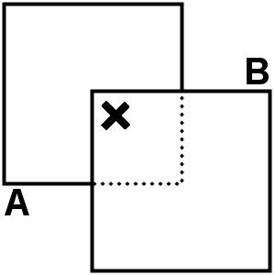
Figure 4: Tile Blending Diagram

Figure 6: Data flow diagram for 3D model download/conversion/rendering system.

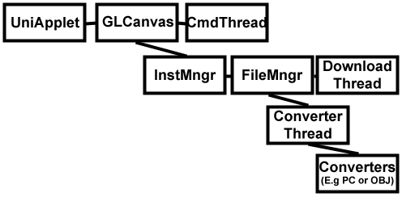
Figure 7: Dependencies in main UniApplet classes.

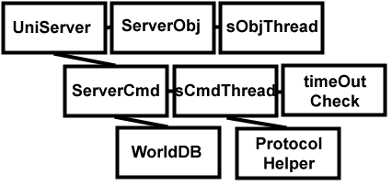
Figure 8: Dependencies in UniServer classes.

