Jasper User Manual

Key features of the interface
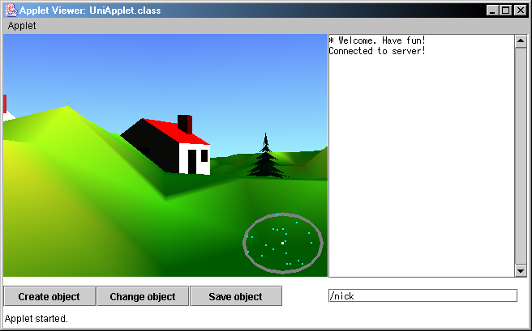

3D view

Output Box

Radar

Object buttons | Input Box

When you load Jasper, you will be presented with a scene similar to the one above. To walk around use the arrow keys.

Choosing a nickname

To begin talking you need to choose a nickname. You will see the /nick command written in the input box, type a name after this to choose a nickname.

For example:
/nick Jonathan Waller

If you make a mistake, you will be told that you are a Guest, and instructed to choose another nickname. Just retype /nick and choose a new nickname.

Chatting
Once you have a nickname, just type your message in the input box and press enter. Your message will be seen by everyone.
You may also type in other languages if you wish. You can type into Jasper in exactly the same way you would type into other programs, using a different keyboard mapping or an IME, depending on the language.

Adding an object

Fist click Create object, the leftmost Object button.

This will create a signpost a fixed distance in front of you. You can walk around to move this to where you would like your object placed.

When you have decide on a location, click Change object

This will bring up the selection box below:
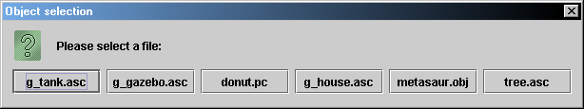

Choose one of these objects, and the signpost will be changed to this new object.

To learn how to import you own objects, see the Extended Features section below.

Once you have decided on the final position of the new object you may click Save object. This will save the object so that all the other users can see it, and will remain there, even when you have left Jasper.

Extended features
There are some commands that are accessed by typing in commands into the input box. Each command starts with a forward slash to differentiate them from chat messages.

/radarpointsize
This allows you to change the size of the points on the radar, the default size is 2. The minimum size is 1 and the largest size is 30.

/objectcreate
Works exactly the same as the button. Creates a signpost, a fixed distance in front of you.

/objecturl
Allows you to import your own objects. Instead of clicking the Change object button, type in /objecturl and type the URL of the object you want to import. For example:
/objecturl http://www.myserver.co.uk/bigcastle.obj

/objectsave
Works exactly the same as the button. Saves your currently selected object to the world.

/getfps
Tells you how many frames per second are being rendered.

/getlocation
This command will tell you where you are in world coordinates. Useful if you want to find somewhere again!

Welcome to Jasper.

